CUSTOMER BEHAVIOUR ANALYSIS PROJECT REPORT
1. Project Overview
This project presents a comprehensive end-to-end data analysis of customer shopping behavior, integrating Python for data preprocessing and exploratory analysis, SQL Server for structured querying and business insights, and Power BI for interactive visualization and reporting.
The objective was to extract actionable insights regarding customer purchasing patterns, segmentation, and revenue drivers, ultimately supporting data-driven decision-making.

2. Objectives
The project was designed to:
- Clean and prepare raw transactional data
- Perform exploratory data analysis (EDA)
- Answer key business questions using SQL
- Build an interactive dashboard for stakeholders
- Derive insights on customer behavior, revenue distribution, and purchasing trends

3. Tools & Technologies
Tool | Purpose
Python (Pandas, NumPy, Matplotlib/Seaborn) | Data cleaning & EDA
SQL Server | Data querying & business analysis
Power BI | Data visualization & dashboarding
Jupyter Notebook | Development environment

4. Data Preparation (Python Phase)
The initial dataset was processed using Python in a Jupyter Notebook.
4.1 Data Cleaning
Key preprocessing steps included:
- Handling missing values
- Standardizing categorical variables (e.g., gender, category)
- Removing duplicates
- Ensuring correct data types (dates, numerical values)
4.2 Feature Engineering
- Derived metrics such as:
  - Purchase totals
  - Customer segmentation indicators
  - Discount flags
- Prepared data for SQL ingestion
4.3 Exploratory Data Analysis (EDA)
EDA focused on:
- Distribution of purchase amounts
- Category-wise sales trends
- Customer demographics (age, gender)
- Subscription patterns
📌 Insert Python EDA Visuals Here

5. SQL Analysis (Business Intelligence Layer)
After preprocessing, the cleaned dataset was exported and loaded into SQL Server.
A structured set of 10 business questions was analyzed:
Key Business Questions
- Revenue comparison between male and female customers
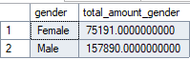

- Customers who used discounts but spent above average
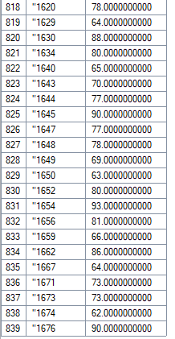
- Top 5 products by highest average rating
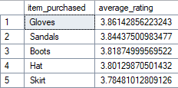
- Purchase comparison: standard vs express shipping
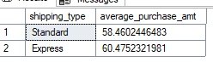
- Spending behavior: subscribed vs non-subscribed customers
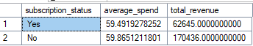
- Products with highest discount usage percentage
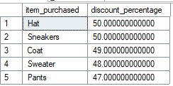
- Customer segmentation: New, Returning, Loyal
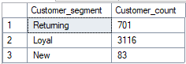
- Top 3 most purchased products per category
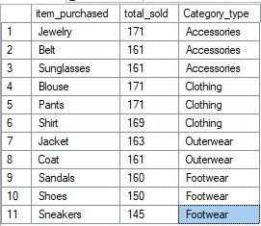
- Relationship between repeat buyers and subscription
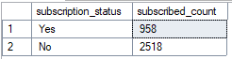
- Revenue contribution by age group
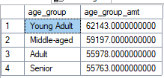
SQL Techniques Used
- Aggregations (SUM, AVG, COUNT)
- Window functions
- Grouping and filtering
- Conditional logic (CASE WHEN)
- Subqueries and ranking

6. Power BI Dashboard Development
A comprehensive dashboard was developed to visualize key insights.
6.1 Key Measures Created
- Total Customers: 3.9K
- Average Purchase Amount: $59.76
- Average Review Rating: 3.75
6.2 Dashboard Components
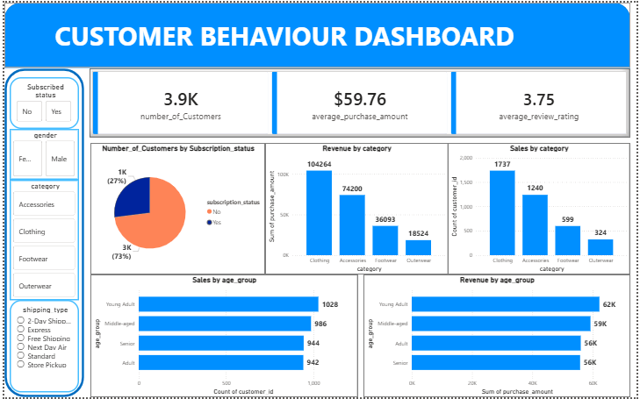
6.3 Dashboard Breakdown
A. Customer Distribution
- Pie chart showing:
  - 73% non-subscribed customers
  - 27% subscribed customers
- Indicates a large opportunity for subscription growth

B. Revenue by Category
- Clothing dominates revenue generation (~104K)
- Accessories follow (~74K)
- Footwear and Outerwear contribute less

C. Sales by Category
- Clothing: highest number of purchases
- Outerwear: lowest engagement

D. Age Group Analysis
- Young Adults and Middle-aged customers:
  - Highest purchase counts
  - Highest revenue contribution
- Seniors and Adults show relatively lower engagement

E. Filters Implemented
- Subscription status
- Gender
- Product category
- Shipping type
These filters allow dynamic exploration of customer behavior.

7. Key Insights
7.1 Customer Behavior
- Majority of customers are non-subscribers
- Subscription adoption is relatively low but impactful
7.2 Revenue Drivers
- Clothing is the primary revenue generator
- Young adults are the most valuable demographic segment
7.3 Purchasing Patterns
- Discount usage does not necessarily reduce revenue
- Repeat customers show higher engagement and potential subscription likelihood
7.4 Business Opportunities
- Increase subscription incentives
- Focus marketing on high-performing categories (Clothing, Accessories)
- Target young adults for retention strategies

8. Challenges Faced
- Data inconsistencies during cleaning phase
- Aligning schema between Python and SQL Server
- Ensing accurate aggregation across multiple dimensions
- Designing a dashboard that balances clarity and detail

9. Conclusion
This project demonstrates a complete data analytics pipeline, from raw data processing to actionable business insights.
By integrating Python, SQL, and Power BI:
- Data was transformed into meaningful insights
- Business questions were systematically answered
- A professional, interactive dashboard was delivered
This workflow reflects real-world data analytics practices and highlights the ability to:
- Handle end-to-end data projects
- Translate data into decision-making tools
- Communicate insights effectively through visualization

10. Future Improvements
- Integration of machine learning for customer prediction
- Deployment of dashboard to cloud (Power BI Service)
- Real-time data pipeline implementation
- Advanced segmentation using clustering techniques

